# Technology stack

* The Backend of Food truck Finder Api is implemented using Asp.net core 6 minimal api. Minimal api is the latest the approach to develop RESTful microservices with minimal dependencies.
* Angular 13 as single page application
* Food Truck Source. Data are stored as a csv file in api project. This source is cached in-memory for fast retrieval. CSVHelper nuget package is used to read CSV file and convert it into in-memory data collection to be consumed in LINQ queries.

# Application Configuration

FoodTruck api configurations are stored in settings.json file and those used to control the dynamic configuration in the application. Since, application does not use any secrets or keys, there is no requirement to use a secret vault or environment variables.

**MedianLocation - This setting contains city coordinates and the max distance between two coordinates in the city. For instance**

**"MedianLocation": {**

**"Latitude": 37.7749,**

**"Longitude": -122.4194,**

**"DistanceInKms": 15**

**},**

**AllowedDomains - Governs the CORS policy. This allow which domains could request data**

**MinRecordsToView - Governs minimum search records count to return from a query**

# Architectural Design

**Middleware pipeline**

**(**Error Handling Middleware**)**

**FoodTruck Api**

**(**REST endpoint**)**

InMemory Data

CSV Data

**FoodTruck Service**

**(Business Logic layer)**

**Unit Tests**

**FoodTruck Domain**

**(Models, Entities, Contracts)**

## FoodTruck Api

|  |  |  |
| --- | --- | --- |
| Endpoint | Description | Parameters |
| Get – Http GET | Search Food truck | ​/FoodTruck​/{latitude}​/{longitude}​/{foodsearch} |
| GetByAddress – Http GET | Search Food truck by address | /FoodTruck/{location} |

## Design concepts

Distance between two geographical location is calculated using Haversine formula. This formula calculates the great-circle distance between two points on a sphere. All the distance are calculated using Kilo meters (km)

# Unit testing

Api methods are unit tested using XUnit. In-memory provider for CSV data source is configured for unit testing

# System Constraints

Food truck api is designed to search closest food trucks by given coordinates using Haversine formula. This calculation is CPU intensive operation rather than IO intensive operation. Hence, to minimize unnecessary calculation the API calculates if the provided coordinates are within the city premises. To provide a generic solution, the api is configured with city coordinates and the maximum distance within two locations in the city. For instance, we could use Google maps to find city coordinates and maximum distance between two coordinates within the city. If the distance between user and city is more than the configured distance, it is assumed that the user is outside the city premises and hence calculation is not performed.

# Api documentation

Swash documentation is used to document api endpoints. The documentation describes endpoint name, Type (GET, POST, etc), parameters, response codes (Http 200, 400, etc)

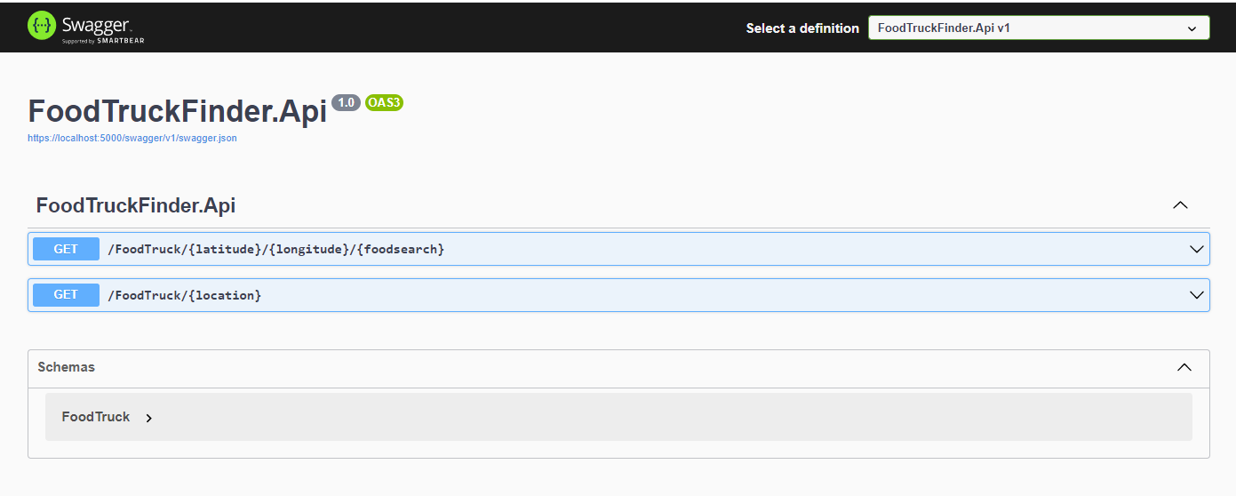

# Improvements for the next phase

Following suggestions can be used to improve the system in terms of features, performance, scalability, and security.

* Provide social media sign-in option to authenticate users using Oath 2.0 and retrieve user information such as users name and profile picture. This information could used to rate the food trucks and feedback. The rating information could be utilized to search food truck.
* Cache search results for faster retrieval based on geographical location.
* Containerization of Api and Client application for deployments, portability and scalability.
* Devops pipeline configuration to build and deploy api and client to a cloud infrastructure. This approach is ideal as it does not require maintenance of infrastructure and security.

# Client-side technology stack

* Angular 13
* google maps package
* Angular Core UI Admin template
* Bootstrap